SPH4U Laboratory Project: Rocketry – Making Rockets!

Dear Physics Class,

Congratulations! You’ve just started your own company and the Canadian Space Agency (CSA) has contracted you as one possible source for rockets in their Mars colonization project. The initial qualifying run involves the launching of a scaled down version of your proposed rocket, measuring its height, and a safe landing/descent of the rocket. Since you’ve always liked shooting off rockets, you figure that this should be easy. However, in the real world of manufacturing (and this competition) it takes much more than shooting the rocket to make a successful project.

Even if your rocket outperforms the others, if it costs one billion dollars more than any other to build and manufacture, you will not be given the contract. Furthermore, if you provide your customer with poor financial and technical analysis, the customer will be less inclined to consider your rocket.

Consequently, thorough financial and technical analyses are considered as high of a priority, in the eyes of the customer, as a great flying rocket.

The final consideration is time. In high school, you may miss a deadline and get away with it, but in business, missed deadlines mean lost contracts. As a result, if you miss a deadline here, you lose the contest and receive zero (0) points. On launch day, three (3) criteria must be satisfied for you to receive credit.

1) All group members must be present at the launch.

2) The rocket and plans must be ready (complete).

3) The rocket must fly without exploding, and deploy its parachute safely and effectively.

THE PROJECT:

Briefly stated, each vendor (group of students) shall supply the customer (Matt) with an affordable, reproducible rocket.

Each rocket must be based on a conventional model rocket, like those one can purchase from stores such as TOYS R US or any online rocket shop. Any modifications to conventional designs require prior approval from your teacher. Failure to adhere to this clause constitutes grounds for elimination from the competition.

GROUP STRUCTURE:

Each vendor (group) may have of no more than 4 students and no less than 2 students. All group members are obliged to participate in some phase of the project. Therefore, meetings are necessary and may take place in the Science Lab either in class or during Homework Hub hours. Meetings outside of school will be necessary as well.

I suggest that you divide up the labor. Someone who is good with money, finances, and shopping should be the accountant/buyer. Another person who is handy could assemble the rocket and write a procedure for assembling it. If someone is handy with computers, this person’s responsibility might be the top assembling drawing (shown in the Appendix) and the 3D design using TINKERCAD. The final person should be the most responsible one, who can assemble the report and perform the required physical analysis. Everyone needs to review and sign off on the report before it is turned in.

CONTRACTUAL OBLIGATIONS:

The project is comprised of 3 phases discussed below:

- The Brainstorming and Proposal Phase ( Due: ________________ )

- Make a rough sketch of the rocket, assign jobs to each member and create a schedule for completing the project.
- Present a cost estimate, schedule, list of individual responsibilities and rough sketch to the customer (Matt).

- The Design and Assembly Phase: ( Due: ________________ )

- Complete a detailed 3D drawing of the rocket using TINKERCAD
- Write a parts list of everything going into or on the rocket.
- Build the rocket.
- Write an assembly procedure for making the rocket.

- The Test and Evaluation Phase: ( Due: ________________ )

- Launch the rocket.
- Perform a physical analysis of the rocket.
- Turn in the FINAL REPORT

FINAL REPORT:

Includes:

- General introduction.
- Proposed schedule and actual schedule.
- Cost analysis (see attached example).
- Top assembly drawing (see Appendix example) and the Tinkercad 3D drawing.
- Set of instructions for assembling the rocket.
- Physical analysis of the performance of your rocket.
- Conclusion with summary comments.

BASIS FOR EVALUATION:

The final score for your project will be based on cost, drawing accuracy/clarity, the final report and performance. The winner is the vendor who receives the most points out of 200, provided someone receives at least 175 points. If no one receives 175 points or more, then no winning vendor will be chosen. The breakdown for scoring will be as follows:

Performance (height And Safe Landing) | 100 Points
Schedules | 10 Points
Cost Analysis | 10 Points
Drawing Accuracy/clarity | 10 Points
Assembly Procedure | 10 Points
Physical Analysis | 40 Points
Overall Report | 20 Points
Total | 200 Points

COST ANALYSIS:

A cost analysis report lists the expenses incurred by the vendor in the production of their rocket. Three items are considered in a typical cost estimate: actual cost of the materials, labour and overhead.

Obviously, the less you spend the better off you are, however, if you go too cheap the rocket’s performance may suffer. You need to optimize your expenditures so that you build an inexpensive yet cost effective rocket.

MATERIALS:

It is necessary to provide a complete list (with receipts) as to what you spent on your rocket. For example:

Items | Cost ($)
Rocket Kit | $45.00
Glue | $3.00
Paint | $2.50
Engines | $12.70
Total | $63.20

In this case, your materials cost is very low when compared to the cost of a real test rocket. So, for your cost estimate you need to multiply the materials cost by 100. In this example the total cost would be $6320.00 instead of $63.20.

LABOUR:

Each individual has different responsibilities and different pay scales. Managers make more than accountants, accountants more than engineers, engineers more than draftsmen and draftsmen more than assembly workers. Each person will spend several hours working on some element of the project (be sure to reference who did what and where you found your information). For example:

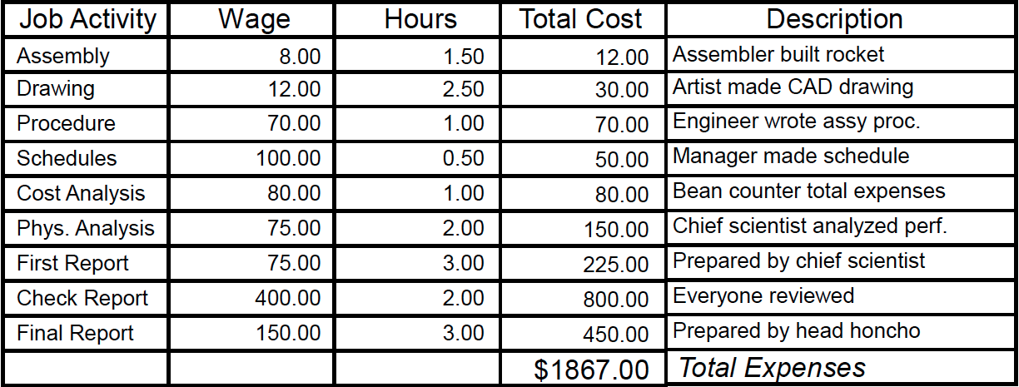

OVERHEAD:

Overhead is essentially all of the money spent on salaries to support people who did little to nothing in the project (like the president of the company or the superintendent of a school district). In most large companies, a tremendous amount of overhead exists. That is, many people get paid while only a few do any work. In North American industry, an overhead factor of three (3) is considered pretty good (at Hughes it was something like 123,634).

In this section of your report, take your total cost of labour and multiply that by three. In this example:

Overhead = 3 x $1867.00 = $5601.00

TOTAL COST:

Last of all you need to total your cost by adding the three elements together. Using this example:

TOTAL: $6320.00 (Parts) + 1867.00 (Labour) + 5601.00 (Overhead) = $13,788.00

GRADING:

The group with the lowest cost will receive the maximum total of points on this section while others will receive some fraction of that amount. Anyone caught committing fraud gets zero points and will be sent to jail.
PHYSICAL ANALYSIS:

In this section you’ll make calculations regarding the acceleration of the rocket, the force it endures, the energy expended, and figure out a means by which you may calculate the height it reaches.

The following data are needed for your calculations:

Lab Data:

- Mass of Rocket without Engine(s)
- Mass of Engine
- Mass of Burned Engine
- Mass of Rocket with Engine
- Mass of Rocket with Burned Engine

Launch Data:

- Flight Time (Launch to Apex)
- Observer Distance from Launch
- Angles of Inclination (Observers)

Calculations:

- Find the height attained by the rocket.
- Calculate the average velocity.
- Find the minimum acceleration.
- Find the minimum force generated by the rocket.
- Determine the energy expended by the rocket.
- Determine the average power of the rocket engine during the flight.
- Using conservation of momentum, what was the speed at which the fuel was expelled from the rocket?
- Draw approximate graphs for the:

- Position v. time of the rocket
- Velocity v. time of the rocket
- Acceleration v. time of the rocket

- Calculate the % difference between the predicted height by the manufacturer and your measured height.

Discussion:

- Summarize the results and your calculations.
- Discuss any findings that surprised you.
- Explain any differences between the measured height and that predicted by the manufacturer.
- List possible modifications that could improve your rocket’s performance.
Background Info: Introduction to Rocketry

Introduction:

The basic components of a model rocket are as follows:

- Rocket Motor. This is a chemical-fueled action-reaction motor. The ones we’ll use are made by Estes Corporation. When handled correctly, they’re virtually foolproof, extremely reliable and incredibly safe.

- Body Tube. This is a tube made out of lightweight, non-metallic materials. A paper towel roll would suffice, unless you want to fabricate your own tube in some way. Fins, which provide the necessary drag to prevent tumbling of the rocket during flight, are glued on to the lower third of the body tube. The fins must be extremely lightweight and rigid. Balsa wood is perfect.

- Launch Lug. This is a thin tube attached to the body tube, whose function is to guide the rocket along the launch rod to that it leaves the launch pad flying straight.

- Recovery System. The rocket motor, described in more detail below, is equipped with a small ejection charge, whose function is to blow off the nose cone of the rocket. Before launch, a parachute is stuffed into the main body of the rocket, as well as a few sheets of recovery wadding, which protect the parachute from the hot gasses of the ejection charge.

- Nose cone. The function of the nose cone is to present a profile of minimum air drag to the wind. Generally, a paraboloidal shape is ideal. It can be made of almost anything, but a smooth finish is crucial. The lower portion of the nose cone must be tapered slightly so as to fit snugly into the body tube. However, the fit must not be so tight as to impede ejection.

Stability Considerations:

- The Centre of Gravity (CoG) is the point at which gravity can be considered to act on the rocket.
- Any object flying through the air is liable to tumble about its centre of gravity, unless aerodynamics has been properly taken into account.
- Any object flying through a fluid has another important point on it called its centre of drag (CoD), which is the point at which all the drag forces can be considered to act on the object.
- If the CoD is ahead of the CoG, then the object will experience a torque due to drag about its CoG which gets bigger as the angle of attack gets bigger. Thus, the object will tumble through the air. Clearly, this is no good for a rocket.
- On the other hand, if the object’s CoD lies behind its CoG, then any torque due to air drag will tend to minimize the angle of attack, bringing the object back to proper alignment with its direction of motion.
- In other words, a rocket with fins providing drag to the lower half of the rocket will fly nice and straight.
Stability Test:

To test for stability, use the whirl test:

- Locate the rocket’s CoG.
- Tie a 2.0 m length of string to the rocket at this point. The rocket should then hang horizontally.
- Whirl the rocket around with the string.
- If it flies right, then its CoD is behind the CoG, and it will fly stably off the launch pad.
- If the rocket flies sideways or backwards, then you need bigger fins!

Model Rocket Flight:

The flight of a model rocket consists of four well-defined phases:

- Thrust. Here, the motor is firing, accelerating the rocket into the sky. At the end of the thrust phase, the rocket has attained its maximum speed, and will coast upward even after the rocket's fuel has burned out.

- Coasting. After the rocket's fuel has been expended, a delay charge, like a slow burning fuse, burns for a set amount of time. This charge provides no thrust, but allows the rocket to coast upwards, its upward speed gradually reducing as it gains altitude to reach apogee, its maximum height above the earth.

- Ejection. After the rocket has coasted for a set amount of time, the delay charge communicates fire to an ejection charge, which pops the parachute. At this point, the rocket, if it was progressing upward, quickly stops and begins to fall.

- Recovery. The rocket drifts safely back to Earth, slowed by the parachute.

Rocket Motor Specifications:

Every rocket motor we'll use is inscribed with a letter and two numbers.

Ex: A8-3

The letter indicates the total impulse in Newton-seconds. An 'A' rocket motor has a total impulse in the range from 1.25 to 2.50 N.s. A 'B' rocket motor has double the total impulse of an 'A'. A 'C' rocket motor has double the impulse of a 'B', and so on.

The first number indicates the average thrust in Newtons. In this case, the rocket exerts an average thrust of 8 Newtons.

The number following the dash indicates the delay between the finish of the thrust phase and the ejection phase. In this case, the rocket will coast upward for 3 seconds before the ejection charge pops the parachute.
APPENDIX: Project Resources

i. Where to Buy Materials:

www.allrocketengines.ca

ii. Example of Top Assembly Drawing:
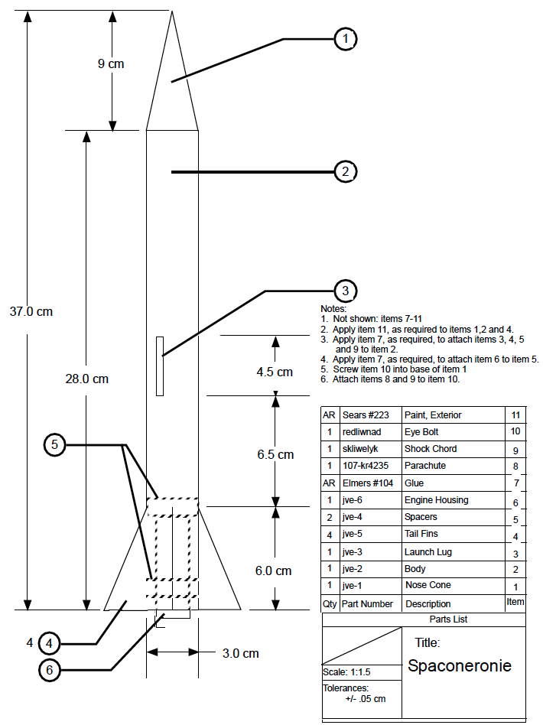

iii. How to Calculate Stability of a Model Rocket:

http://www.wikihow.com/Calculate-Stability-of-a-Model-Rocket

iv. How to Launch a Model Rocket Safely:

www.wikihow.com/Launch-a-Model-Rocket-Safely

v. How to Calculate Height of a Rocket Launch:

- When one teammate launches their rocket, the other partner will use the Estes Altitrak™ to collect the launch data for their teammate’s rocket launch.

- Procedure Example: (For a Rocket with an expected Max Height (apogee) of 300 m)

- Measure and mark 300 m from the launch pad.
- The partner (tracker) using the Altitrak™ will stand here.
- The tracker will hold the Altitrak™ at arm’s length, pointed at the rocket, pull and hold the trigger then signal for the launch.
- Tracker will track rocket through forward sight. When the rocket reaches maximum altitude (apogee), they will release the trigger.
- Partners will record the Altitude in Meters from the Altitrak™.

